Lei Liu #104651816

# Purpose

This website aims to offer users a review and rating space to celebrities, including musicians, actors, models, athletes, hosts and authors.

Public internet link: <http://lei6745.pythonanywhere.com/>

Github link: <https://github.com/Lei1025/RateMyStar>

Demonstration video: <https://youtu.be/-idpnqSUwmk>

# Technology

* Python 3.6
* Django
* Html
* CSS
* bootstrap
* JavaScript
* JQuery
* Linux server

# Index

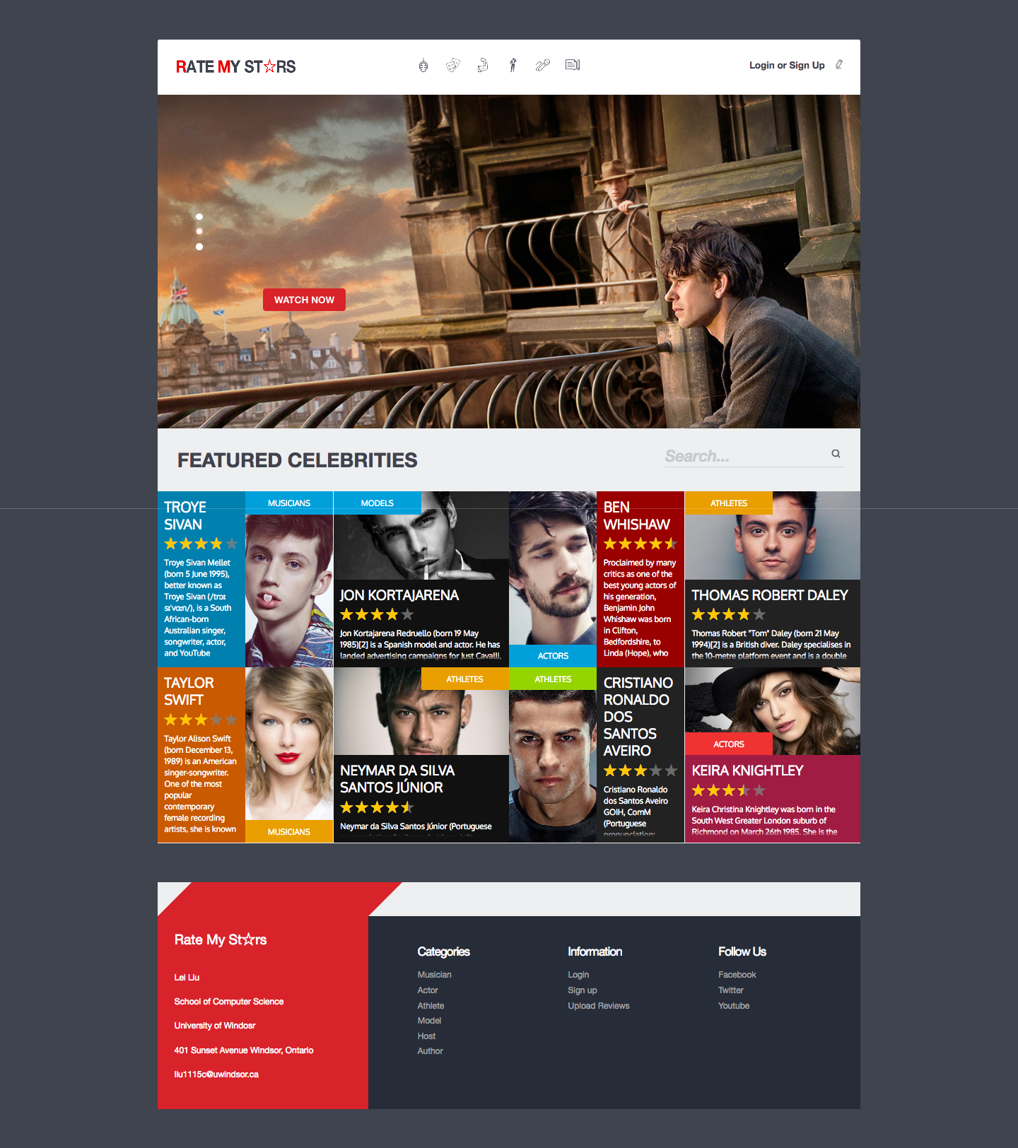

## Head

The Head contains three parts. On the left side， a website logo, RATE MY STARS, is shown. If being clicked, it will return index. A navigation bar is located in the middle, containing six occupations of celebrities to be further checked. It uses a method of hover to display the specific name of an individual star type if the cursor moves to its icon. User’s information is shown on the right side. A button called LOGIN can redirect to login pages when being clicked if a user has not logged in. But if a user has already logged in, it will become a button for logging out and the Head will show his/her head portrait. Moreover, a logged in user can be straight redirected to upload page when user clicks the name.

## Footer

On the left side of footer, there is a display panel listing personal information of the current user. On the other side, some quick links, sorted by Categories, Information and Follow us, are provided for a user to enter another desired website conveniently.

## Banner

The editor has chosen three celebrities for the banner. The banner displays one of them at a moment. A user clicks a button called WATCH NOW to enter the detail page of the selected celebrity.

## Featured content

The featured content listed all categories in random order. Each category shows its category name and a portrait photo of a randomly selected celebrity in this category, as well as a brief content of the reviewed article of this celebrity. JavaScript is applied to control animations on the portrait and brief description in each category. For any category, when the cursor moves to one of them, the other one will be hidden automatically. Besides, there are links to the detail page of a corresponding celebrity on the portrait photo and names.

## Search

A field called Search is capable of looking up related information of specific content, on which a method of fuzzy search is implemented. By clicking a magnifier icon, a user can be redirected to a result page, which is actually a child page of category.html.

# Users related function

## Login

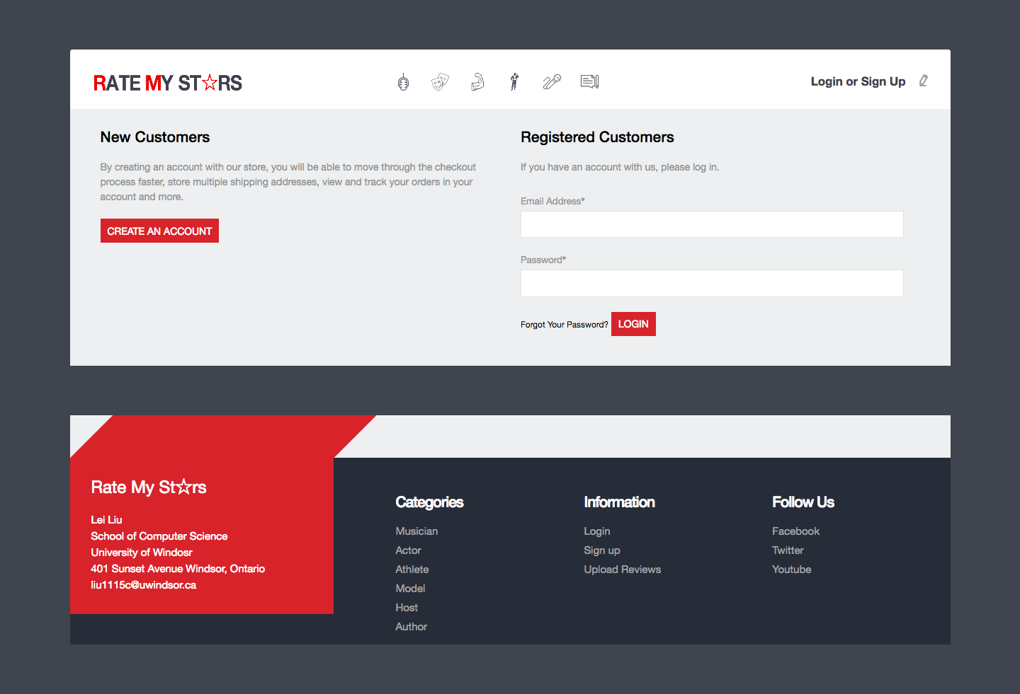

On the left side of this website, a button of CREATE AN ACCOUNT is designed of a user who has not had an account. It links to another website to create a new user.

On the other side, a registered user can type his/her email address and password on the specific input boxes separately, and then log in by clicking the button of LOGIN. If an unregistered user tries to log in without creating an account, an error message will be returned.

## Sign up

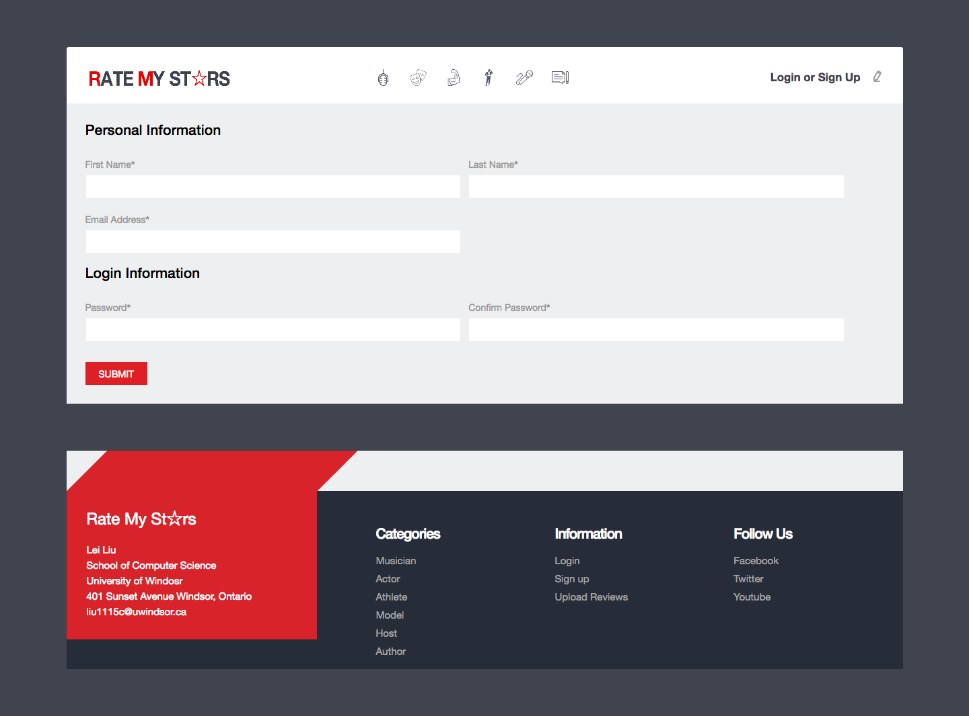

To sign up and created a new account, a user needs to type his/her first name, last name, email address and password as well as a conformed password on separated input box. A button of SUBMIT can upload the above information after being clicked. If a user signs up successfully, a username, in the format of firstname.lastname, will be generated automatically. For example, a user signed up with Lei as first name and Liu as lastname, as a result, username will be automatically generated in the format that Lei.Liu .In the page, an information check is applied. For example, the password will be double checked by being compared with confirmed password. If they are not the same, an error message will return.

## Forget password

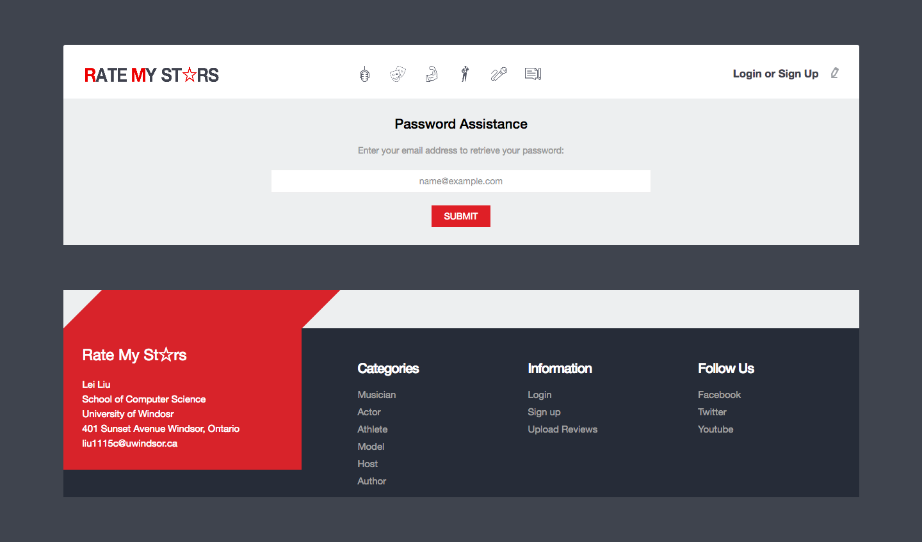

A user who has forgotten the password can type his/her e-mail address on the specific input box and submit. The server will send an confirmed e-mail to this address.

# Category

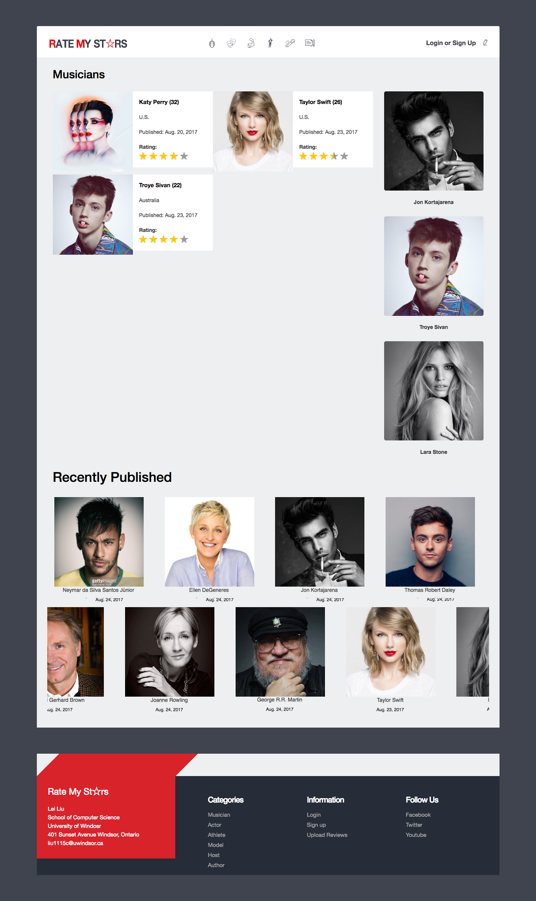

## List of corresponding occupation

This part lists all the stars of the selected occupation arranged in alphabetical order, each of which would show his/her portrait and describe the star name, nationality, published date and rating. If clicking the star portrait, a user can then enter the detail page of the corresponding star.

## Sidebar

On the right side of Category, Sidebar randomly chooses three stars to display from the whole database regardless of occupations. But it will only display the portrait and name of each star.

## Recent publishes

Ten most recently published articles are in scrolling display programmed by JavaScript. Different from Category, the content of each star only contains his/her portrait, name, published date. But in the same way, if clicking the star portrait, a user can then enter the detail page of the corresponding star.

# Detail

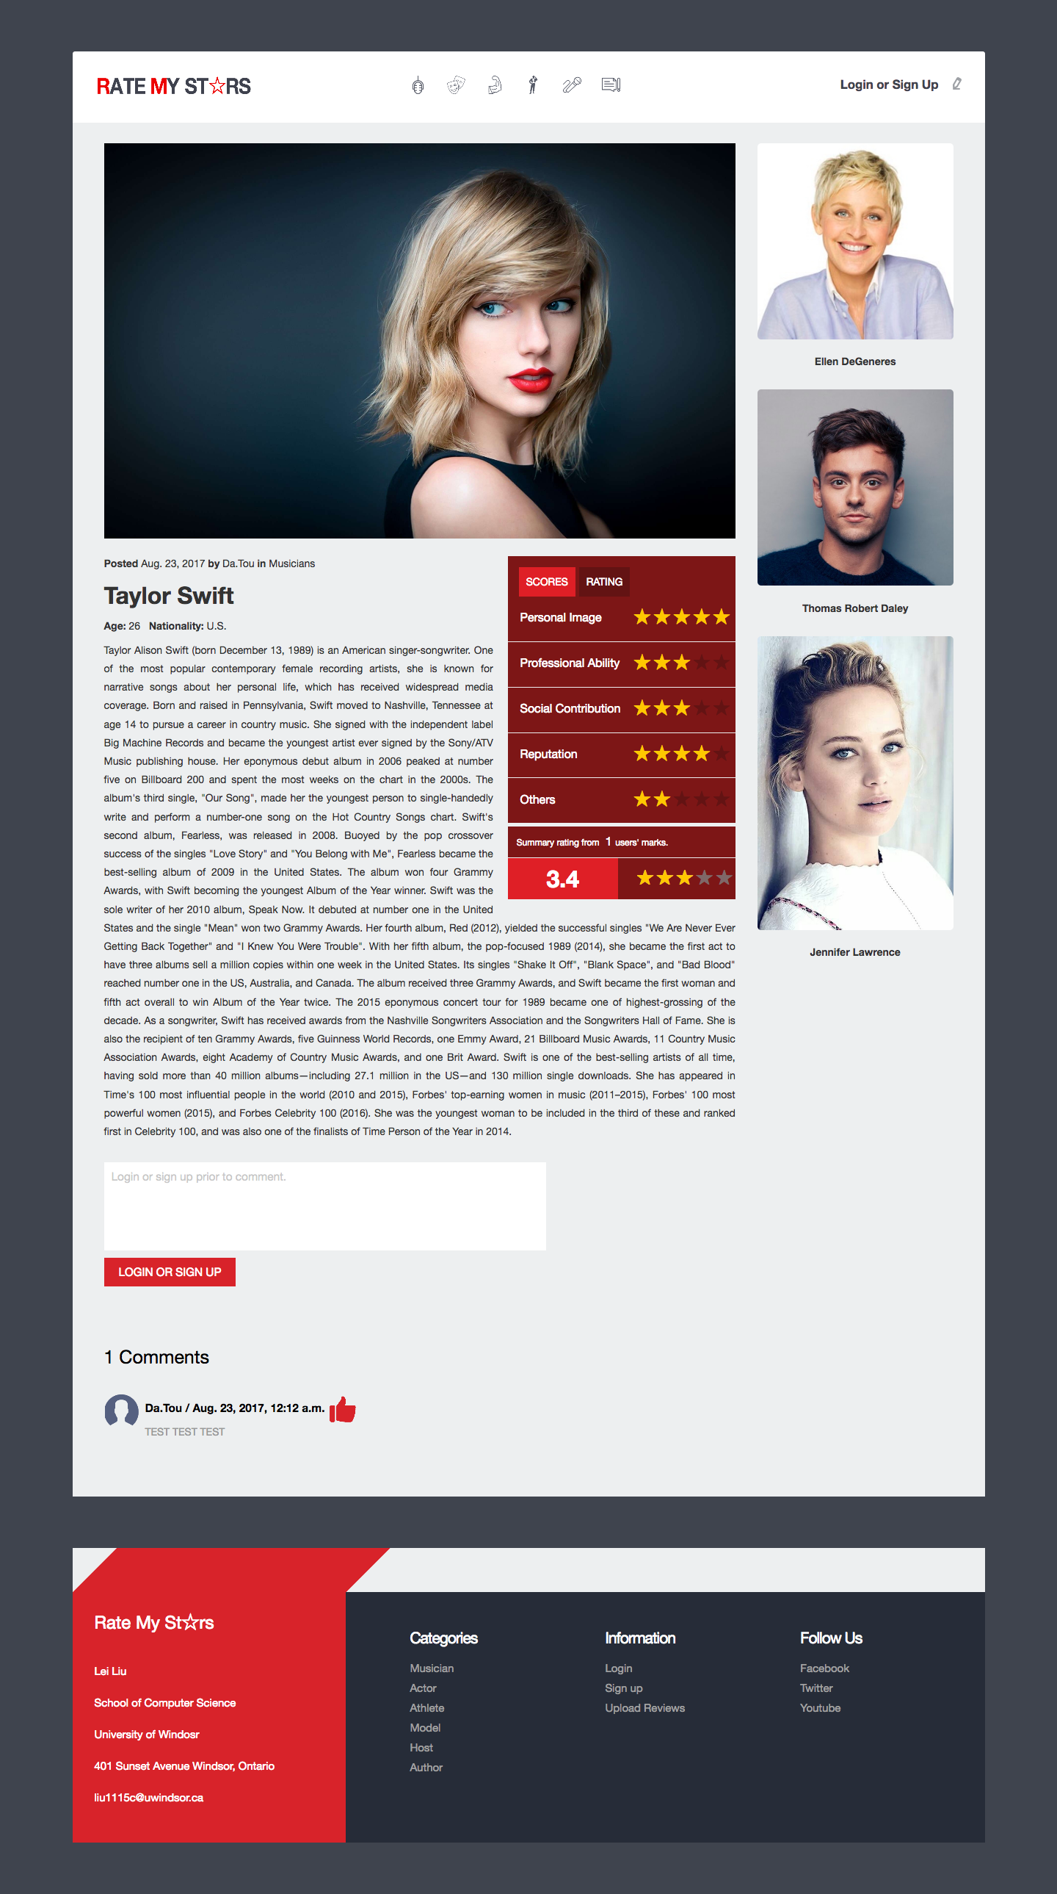

## Content

A large banner is firstly shown at the center, below which an annotation introducing the posted date, uploaded user and occupation locates at the left side. Then the specific star is detailed described including his/her name, age, nationality and concise biography.

## Rating

A rating widget is located at the right side of the star’s description. JavaScript and JQuery have been implemented on this part to make it functional. It is divided into two pages. One is called SCORES, which firstly contains the averages scores of five criteria to evaluate a celebrity. Under those scores, it will tell the number of users who has rated this star. And the total average value of the above five scores is then emphasized. The other page is called RATING, which is designed for a user to rate this star according to the same five criteria. After rating, the user can click the SUBMIT button. Then a notification will inform the user that he/she has submitted successfully and the rating data will be uploaded. Afterward, the website would be refreshed and the average scores in the SCORES page would also be recalculated.

## Comment

A textbox is deposited for a user to comment a star. If the user has already logged in, he can type his comment and submit. But if the user has not logged in, he/she is not allowed to type any words on the textbox and a button will inform the user to click in order to enter the login page.

A textbox is deposited for a user to comment a star. If the user has already logged in, he can type his comment and submit. But if the user has not logged in, he/she is not allowed to type any words on the textbox and a button will inform the user to click in order to enter the login page.

The total number of comments is then shown below. Then each comment as well as the commented users, his/her portrait and commented date is listed by reverse chronological order. For each comment, a LIKE button appears beside the commented date. If it is clicked, it will change to another color for emphasizing.

## Sidebar

A sidebar is at the right side of this website, which is the same as that in Category page.

# Upload

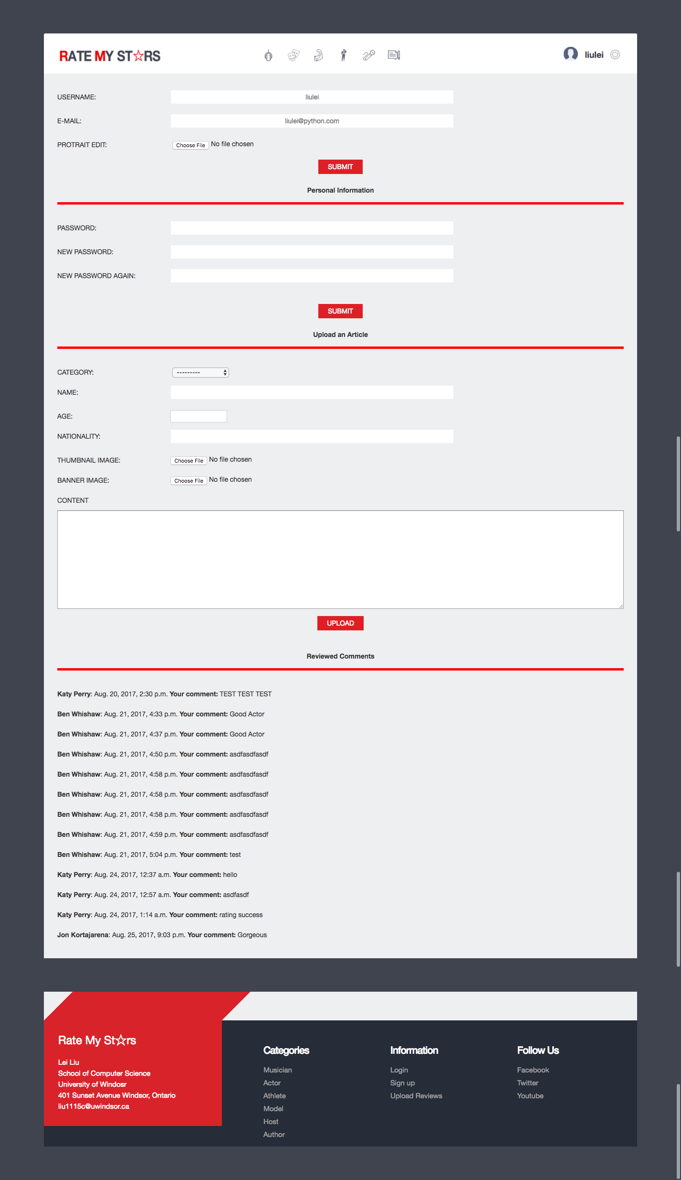

This page is separated into three parts. In the first part, the input boxes of USERNAME and E-MAIL are firm. A user can then upload a portrait photo, whose size is of limited.

In the second part, a user needs to type his/her old password and a new one separately on the corresponding input box. Besides, the new password needs to be typed again to confirm. If the new password and the repeated one are not the same after submitted, an error message will return.

In the third part, a user can upload an article by selecting a given category and typing a celebrity’s name, age and nationality. Then the user can also upload a thumbnail image and banner image of this celebrity. A textbox below is available for a user to comment. Afterward, the user clicks the button of UPLOAD then his/her edited celebrity’s information will be uploaded.